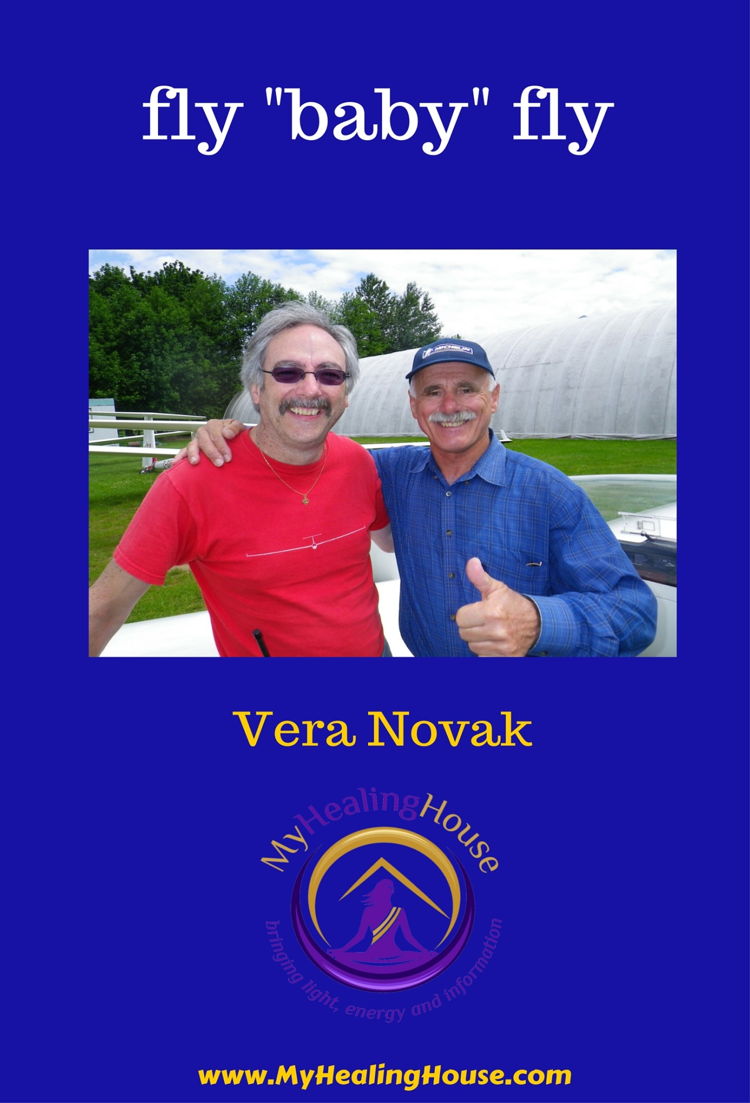

fly "baby" fly

*by Vera Novak*

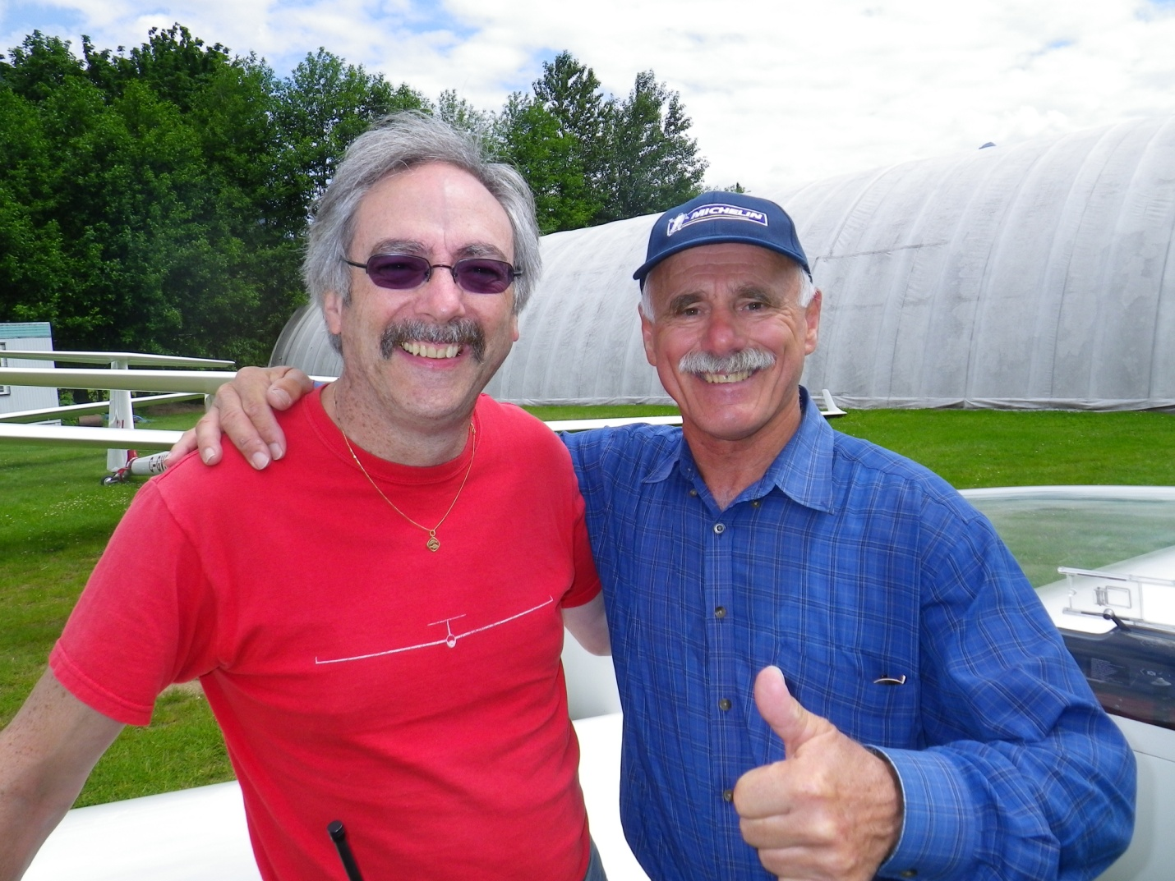

*“fly baby fly”*

My husband Don passed his pilot licence test. It is a glider pilot licence and is a fulfilment of his life dream that was “dusted off” and at long last formulated nine years ago. As you can notice in the picture flying makes him joyful. It is his TRUE LOVE. I would like to share with you what we learned about bringing his dream to reality.

|  |
| --- |
| bigstock-Confused-Woman-Scratching-Her--44040691.jpgDo you get discouraged, frustrated or even depressed when you see others in happy relationships, thriving in their work, having a good time and without financial worries? |

The seed of this dream was with Don for most of his life. He used to mention his regret of not being able to get the pilot licence quite often over the years. He was disappointed that his dream of being a pilot couldn’t come true due to his vision that wasn’t 20/20. In later years he realized that this requirement wasn’t a show stopper as more pilots with glasses were being allowed in. He never took any steps to bring this dream to life. He might have daydreamed or dreamt about it at night, however he took no action.

|  |
| --- |
| Dreams don`t come true, they already are.  But we must be true to them – Derek Rydall |

**ACTION** is as important of a step as all the other steps.

*Anatomy of a Dream*

|  |  |
| --- | --- |
| ***Conceive it*** | *It is the Dream stage* |
| ***Formulate it*** | *Is done in the Blueprint stage* |
| ***Express it*** | *Through Sounds (Wave) - Name it and Claim it* |
| ***Bring it to form*** | *Is the In-Formation - action stage* |

It was in 2006 that he made the wish to have a glider pilot licence. Having a wish like this isn't anything special you might say, but not if you have buried the dream so deep that you don't even know you have it? There are many reasons for skipping any of the steps of manifesting or realizing. One of them could be that you have such self talk that any appearance of anything reminding you of your dream you would shut out immediately. During an intensive process that we invested by working with a coach, his lifelong dream reappeared. We made a huge investment, ten thousand dollars was a serious amount for us back then. We have gone through many personal development classes before and after. This one was a first one that offered looking into **many aspects** of our lives and thus provided an integrative approach.

|  |
| --- |
| *Investing time and energy into discovering the True Self is the greatest investments you can make in my humble opinion.* |
|  |
| Just as the entire oak tree is already potential in the acorn, so too is the mighty oak of your own being already within you. - Derek Rydall |

The processes and tools used were able to help him to go through the Dream Process and complete it successfully. I wish that I understood 10 years ago more about what keeps most of us from:

* Having creative dreams
* Formulating our dreams
* Naming our dreams
* Committing them to form

|  |
| --- |
| *“A person who cannot imagine the future is a person who cannot contemplate the results of his actions. Some are thus paralyzed into inaction.”*  *―* [*Alan Lightman*](http://www.goodreads.com/author/show/8933.Alan_Lightman)*,* [*Einstein's Dreams*](http://www.goodreads.com/work/quotes/1820798) |

*My Dream and what I learned*

I remember being taken aback when Don formulated and expressed his dream of flying. It did not quite fit into my dream of creating 10,000 a month of passive income.

I worked on my Dream/Goal/Plan as well. My Dream wasn't aligned with who I was and with my life purpose however. Because of that it ended up costing me a lot of health issues. At the end I found what I was looking for. What I found was how what we desire in life needs to be aligned with who we are and what we came here to do. Every one of us has a purpose and every one of us is important for the whole humanity to thrive. Humanity has *thriving* in its design. Suffering isn't where we must remain. Certainly there will be challenges and learning which is unavoidable, because that is how we learn and discover our gifts; through challenges. Another important lesson I have learned is that we cannot do our life wrong. All roads lead to the center eventually, it is just a matter of when. ***Is NOW the time for you?***

|  |
| --- |
| *I invite you to disentangle yourself from what is holding you back.*  *Isn't it time to let go of all that isn’t true for you?* |

Don created his dream from the heart and he was able to bring it to reality because such dreams fulfill the soul’s calling. Dreams made from the HEART have an enormous energy that can be made available to them because they align the body in a very beneficial way. I have been partaking in the dreaming process my whole life as were you. We both also have been part of the *collective dreaming*. The images, the words, the music, the stories have been inserted into my dreams, your dreams and our collective waking dream and the dreams we have when we sleep. When we wake up to the powers of dreaming, we change what manifests in our lives.

|  |
| --- |
| The more we fill ourselves up, the emptier we feel. Our materialistic fix just isn`t getting us high anymore. - Derek Rydall |

One of the biggest obstacles to overcome for me was *TRUST*. How do I trust? I fully trust myself now and I know what is good for me on all levels.

*Would you like to be able to TRUST yourself COMPLETELY?*

|  |
| --- |
| *Take back your creative and personal powers.*  *Shine the light from inside out*  *Learn how to TRUST yourself completely* |

How to get more connected…

* Meditate
* De-Condition
* Experiment with your energy design strategy
* Know Yourself (and your circuitry)
* Practice taking leaps of faith
* Learn how to muscle test

Looking back now I see why Don’s dream was successful. He went through a process that allowed him to uncover all that was hidden or suppressed inside of him. Granted it took three years until we sold our investments before he took **ACTION**; one of the universal laws and principals.

**ACTION** is as important of a step as all the other steps.

The last 10 years have taught me more about what dreams with consciousness are about and how to create with what benefits ALL in mind, all while manifesting what our own heart desires. ***The Law of Resonance is now what I use.*** What is the Law of Resonance? It is another take on the Law of Attraction. The way the movie **The Secret** interpreted it I learned later wasn't quite the way it is. First let me list all the Universal Laws that I am aware of, there could be more. I will also explain how I learned the difference between the Law of Attraction and the Law of Resonance through my own experience.

|  |
| --- |
| The more you realize that what you truly want is already within you, the less appeal the outer struggle has. - Derek Rydall |

**12 Universal Law and Principals** you might keep in mind when creating your dreams. This is an extract from Milanovich and McCunes book "The Light Shall Set You Free” (1998)

1. ***The Law of Divine Oneness***

Helps us to understand that we live in a world where everything is connected to everything else.

1. ***The Law of Vibration***

This Law states that everything in the universe moves vibrates and travels in circular patterns. The same principles of vibration in the physical world apply to our thoughts, feelings, desires, and wills in the Etheric world. Each sound, thing, and even thought has its own vibrational frequency, unique onto itself.

1. ***The Law of Action***

The Law of Action must be applied in order for us to manifest things on earth. Therefore, we must engage in actions that support our thoughts, dreams, emotions and words.

1. ***The Law of Correspondence***

This Law states that the principles or laws of physics that explain the physical world - energy, light, vibration, and motion - have their corresponding principles in the etheric or universe. "As above, so below".

1. ***The Law of Cause and Effect***

This Universal Law states that nothing happens by chance or outside the Universal Laws. Every action has a reaction or consequence and "reap what we have sown."

1. ***The Law of Compensation***

This Law is the Law of Cause and Effect applied to blessings and abundance that are provided for us. The visible effects of our deeds are given to us in gifts, money, inheritances, friendships, and blessings.

1. ***The Law of Attraction*** - **LAW of RESONANCE**

The Cosmic Law of Attraction insists that all things similar in nature will naturally gravitate to one another and magnetize one another into their own field. Like attracts like; however if you take two positive magnets towards each other they will actually repel - not attract. The Law of Resonance states that anything that is on the same vibrational frequency makes itself known to each other. They vibrate on the same frequency. In 2010, the year in everything changed for me, a teacher came to my life that taught me the **Heart Resonance**, which propelled me onto a different trajectory.

1. ***The Law of Perpetual Transmutation of Energy***

It states that all persons have within them the power to change the conditions in their lives. Higher vibrations consume and transform lower ones; thus, each of us can change the energies in our lives by understanding the Universal Laws and applying the principles in such a way as to effect change.

1. ***The Law of Relativity***

The Law states that each person will receive a series of problems (Tests of Initiation) for the purpose of strengthening the Light within. We must consider each of these tests to be a challenge and remain connected to our hearts when proceeding to solve the problems. It also teaches us to put everything *into its proper perspective.*

1. ***The Law of Polarity***

This Law states that everything is on a continuum and has an opposite. We can suppress and transform undesirable thoughts by concentrating on the opposite pole. It is the law of mental vibrations.

1. ***The Law of Rhythm***

This Law states that everything vibrates and moves to certain rhythms. These rhythms establish seasons, cycles, stages of development, and patterns. Each cycle reflects the regularity of the universe. Masters know how to rise above negative parts of a cycle by never getting too excited or allowing negative things to penetrate their consciousness.

1. ***The Law of Gender***

This last Law states that everything has its masculine (yang) and feminine (yin) principles, and that these are the basis for all creation. The spiritual Initiate must balance the masculine and feminine energies within herself or himself to become a master and a true co-creator with the universe.

*My Dream*

|  |
| --- |
| *We don`t get what we want, we get what we are* |

***A thing to ponder:***

*There is nothing to get.*

*We don`t get it until we get it.*

My plan was created from the MIND where there is polarity. The movie The Secret influenced many of us and it also influenced my dreaming. I saw that red bicycle like others did. What I did not understand, but learned later, was the nature of the polarized Mind. It has two hemispheres and it creates polarity. The Law of polarity addresses this. When we create from the heart, we don’t create a blowback that creating from the mind causes. I now understand why I ended up with *a burnout.*

When we create from the Mind only, what we also create are the opposite forces that come back to bite us on our arse. Memories came back when I learned this. I could see how this blowback worked in my life. I remembered the weekend I won three radio contests. I also recalled having three car accidents within two weeks. Some valuable lessons were learned during the last nine years that brought me here to talk to you about them.

*Don created a dream that worked with the Law of Resonance.*

*I created a dream that worked with the Law of Polarities.*

We can individually or collectively find ourselves inside of other people’s dreams that become nightmares for us. We have the power to change that. Over the years I have come to see and understand that light and dark both want the same thing and that is **LOVE** which binds us all to this reality. So essentially *there isn’t anything that cannot be transformed.* It is one of the universal laws. Finding the conflicts and the source of the conflicts is how we do it.

The path was cleared for Don in 2009. He joined the *Vancouver Soaring Association* and started working towards his licence. Don loves being out on the field running the operations and socializing. I asked him about how he felt when he made the dream. Did he imagine what it would feel like when he formulated the dream? Many coaches will ask you to imagine that you already have your dream now. He said none of that was true for him. I don’t think that he could have ever imagined the joys his dream brought us when he created it.

*Don made himself a Promise*

|  |
| --- |
| *By my 57th birthday I will have a glider pilot licence and my own glider* |

At this time, there is one need to buy one’s own glider. His club has them and he is more than happy to share them. Sitting at the airfield watching the glider pilots and surrounded by gorgeous blue mountains seeing nothing else but the green grass of the airfield, I often wondered if what they are doing is selfish. It seemed to me that spending all free time on weekends just playing and enjoying their passion for flying was a shallow interest considering all that I perceived to be going on in the world. Today I know that enjoying life and what it has to offer, while bringing their body systems into peace when they fly, is like meditating. I also know now that it isn't selfish. Today I know that what they create through this *joy and peace* benefits all of us. We need more creators of joy in our collective dreaming.

*Let’s practice*

*Technique #1*

**Abundance Manifesto and a Glass of Water**

I am sure that you know by know that you are not alone, you were never alone and there are tools and guides to help you towards your self-realization which includes bringing what is born in your heart into the reality.

This one comes from **www.astroshaman.com**. Benjamin has some free material on his website on invocations. You could use the word prayer, however I do like invocations and activations just because some people have engraved associations in their body field with the word prayer.

#### The Formula

1. State what you want as simply as possible.
2. Add the nine magic words: “to the greatest extent that serves highest good, please.”
3. Close with, “starting now, thank you.”

#### Commentary

1. **State what you want as simply as possible.** Some examples are, “Saturate me with bliss,” “Make me one with my higher self,” and “Integrate my light body and my physical body.” Use the minimum number of words that get your meaning across.
2. **Add the nine magic words: “to the greatest extent that serves the highest good”.** This says to Spirit, “Give me just as much as I can handle, but don’t overload me!” Although the personality must initiate the energy flow, this phrase gives Spirit final control over the process. It also eliminates worry: if you’ve inadvertently asked for something inappropriate, and the greatest amount that serves your highest need is zero, then nothing will happen.
3. **Close with, “starting now, thank you.”** “Starting now” lets Spirit know when to carry out your request, and it’s polite to say “thank you.” Gratitude increases abundance!

A lie believed acts as truth until it is neutralized

Let's examine some of the myths. I found these in the book *There`s no business like Soul business* by Derek Rydall. It could be fun to find more myths to bust.

Myth: It is all in who you know

Truth: The only person you need to know is you

Myth: Some have **IT** and some don`t

Truth: Everyone has equal and infinite potential

Myth: You have a limited, window; once it closes it is over

Truth: It is never too late to fulfill your purpose

Myth: You have to play by the rules to win the game

Truth: The truth within you is the Only Authority

Myth: You need to have the right education

Truth: All knowledge is already in you

Myth: You have to wait until the conditions are right

Truth: Your inner conditions determine outer experience

***Technique #2***

**Abundance Manifesto and a Glass of Water**

Rub your palms against each other to activate the energy flow in your hands and place them around the glass of water. Read the manifesto out loud. Concentrate your attention on the glass of water while visualizing the Abundance Manifesto. This came to me from **Karen Curry Parker**. I am sure that you will have things to add or take away from this list. You are invited to do so. As someone who has been on a journey for a while, you might already have something you could use for the next step. Write your own blueprint of what you want to create. You can put them under the class of water or wrap them around the glass

Remember to first connect to your heart and create something that is in the highest good of all. Also keep in mind that what the creator of the Earth and nature has done is perfect and it isn’t your place to tinker with that, however you are invited to join the forces and create with the natural laws of creation.

|  |
| --- |
| The Abundance Manifesto   1. I am a radiant, magnetic being 2. Abundance is my birthright and my natural state 3. I attract everything I desire into my life with effortlessness and ease 4. I know that unseen loving forces are supporting me constantly 5. I focus my attention and energy on having exactly what I want to manifest in my life 6. I am fully open to the Magic of the Universe helping me with every step of creation.   Miracles happen to me every day   1. I am deeply grateful for all my life experiences   I know they are helping me expand my thinking and my consciousness   1. My positive emotions show me that my attention is in alignment with my desires.   I am on my way to creating exactly what I want   1. I surround myself with people who support my creative process 2. Abundant opportunities are always presenting themselves to me 3. Creation is a constantly evolving process   I am always doing it right  I am always growing and changing   1. I take guided actions that are in alignment with my desires and beliefs 2. I am fully supported, deeply loved and magnificently powerful!   I am an Unlimited Child of the Universe! |

*Maps, Compasses and Guides*

*Human Design*

For some people *making a promise* is detrimental to their health, but not for Don. He also needed an environment in which he could listen to himself. You see Don's energy is such that he operates differently than other people's energies. He is an energy type that in **Human Design** is called Projector.

For an individual that is what we call a Manifesting Generator with undefined Heart/Will center, *making a promise* Don made could compromise his health because of different energies that create different chemistry in the body. Don’s dream was conceived with very good tools, it was correct for him and his commitment did not waver. It became a reality the day he conceived it.

**Human Design**, a new innovative decision-making system, helps people discover their unique decision-making style so that they can start choosing better in life. Human Design, a modern personality analysis tool is a blend of several ancient esoteric sciences including:

|  |
| --- |
| * Eastern and Western Astrology * I Ching * Chakra System * Kabbalah * Quantum Physics |

There are four energy types in the Human Design system: **Projector**, **Generator** (*Manifesting Generator is a sub energy type),* **Manifestor** and **Reflector**. There are many energy systems that divide people into energy types, Human Design is one of the more complex ones and it compliments all the other ones. It helps us how to master the invisible energies of our Human Design bringing them to their highest expressions. It helps us to **discover our hidden divine gifts that are within us.**

Each person’s unique Human Design is calculated using their birth information, just like a traditional astrology chart. But the result of this calculation is unlike any other personality analysis tool on the planet. A Human Design chart is literally a “map” of how a person uses their energy, where they are sensitive, where they are predisposed to certain behavioral patterns, their strengths, their challenges, their life purpose and, most importantly, their way to make decisions.

There are **nine energy centers** in Human Design and one of them is Heart/Will center. An individual would have such center defined or undefined. The defined energy center would have energies that are more fixed. Individuals with undefined centre have unlimited way or operating from such centre.



I went on my own healing journey five years ago. I realized the load of creating passive income had on my health*. I learned why we get sick, how to get well, and how what is good for one person isn’t beneficial for another.* There is nothing more compelling than when we are aligned with our energy types. Only then we can start the process of going from low expression of these energies to their higher expressions do we see beautiful results.

*Where have you STOPPED yourself pursuing what you really want?*

It is my passion to help my clients achieve their dreams and clear what is in the way such as:

* Negative patterns
* Illness
* Bad Relationships
* Lack of finances
* Career challenges

|  |
| --- |
| ***From the bottom of my heart I wish you well on your path of falling in Love with Life, Yourself, your Life Purpose.***  ***I want you to THRIVE, be abundant, healthy and joyful***  ***It is in your Human Design and it is your Destiny*** |

***Your journey and how I can assist you***

* Looking at the money conundrums that are in your Human Design charts
* Examine relationship to *money* and *energy* of what you value
* Help you to engage in a spiritual practice that creates conscious positive change for you in relationship to money
* Find peace and happiness from within by shifting what is in the way of becoming your TRUE SELF
* Establish communication with your True Self on all levels
* Clear the channel of communication with your guides, fairies, power animals, ascended masters, ancestors and teachers to guide you on your spiritual journey. As you learn to TRUST yourself this connection will become stronger and stronger.
* Learn to distinguish where this guidance is coming from and establish safe and protective environment for yourself through trusting yourself.

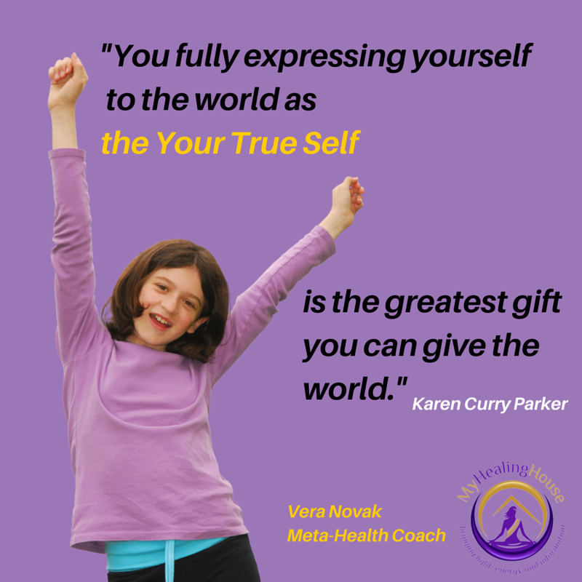

***I offer these consultations:***

**Getting familiar with your own Human Design.**

This will help you to understand your energies and your strategy that will help you on your path to your dreams

**Contact me with Date, Time and Place (including a country of birth) if you would like me to run your chart**

**Follow up consultation** **45 minutes and cost just $125.**

To book a session go here:

[**http://www.myhealinghouse.com/services-meta-health-coach/**](http://www.myhealinghouse.com/services-meta-health-coach/)

**META-Health Consultation** offering a synthesis of the latest advancements with life coaching, therapy, Emotional Freedom Therapy and energy psychology

Are you looking to release stress, let go of unwanted patterns, define and achieve your goals or gain greater well-being? Then it's probably the right time for you to have a META-Health Awareness Consultation.

**META-Health Consultation is** **60 minutes and cost just $150.**

To book a session go here:

[**http://www.myhealinghouse.com/services-meta-health-coach/**](http://www.myhealinghouse.com/services-meta-health-coach/)

**How Will A META-Health Consultation Benefit Me?**

You will gain an understanding of META-Health, how it can help you, and get to ask all of your heath questions.

During this conversation we will discuss either a current health issue for which you'd like to reach a META-perspective, or we can discuss your specific interest in META-Health and its applications in life and career.

You'll get to explore the key problem in your life and gain a META-Perspective on what's really going on, why it's there, and how to resolve it.

**After your initial META-Health Consultation you may select**

**META-Health Coaching Session** to uncover your hidden barriers.

In this introductory session we will explore your current goals in life, current health challenges and uncover what **internal barriers are preventing you from achieving** the life, relationships, health and career that you desire.

We will proceed to identify core self-limiting beliefs, emotions, memories, programs and internal conflicts that are preventing your from having what you desire in life, work and personal life.

This session will give you a plan of action for further coaching or energy work

**META-Health Coaching Session** **is 2.5-3 hours and cost just $500.**

META-Health Consultation is the prerequisite

To book a session go here:

[**http://www.myhealinghouse.com/services-meta-health-coach/**](http://www.myhealinghouse.com/services-meta-health-coach/)

After your initial META-Health Consultation may select

# META-Kinetics Health Scan®

Gain an overview of how stress is impacting your body, find out your number one priority for healing, and release the stress from it!

In this session, we will take information gathered from the previous session and work with the feedback of your body's wisdom so as to work in more depth to discover the body field's priorities for healing.

We will use META-Kinetics Advanced Kinesiology to gather information such as biggest unconscious stressors, associated memories, related health issues and beliefs, values motivations and behaviours involved.

**META-Kinetics Health Scan** **is 2 hours and cost just $350.**

META-Health Consultation is the prerequisite

To book a session go here:

[**http://www.myhealinghouse.com/services-meta-health-coach/**](http://www.myhealinghouse.com/services-meta-health-coach/)

**www.MyHealingHouse.com**

myhealinghouse@shaw.ca

604.230.3390

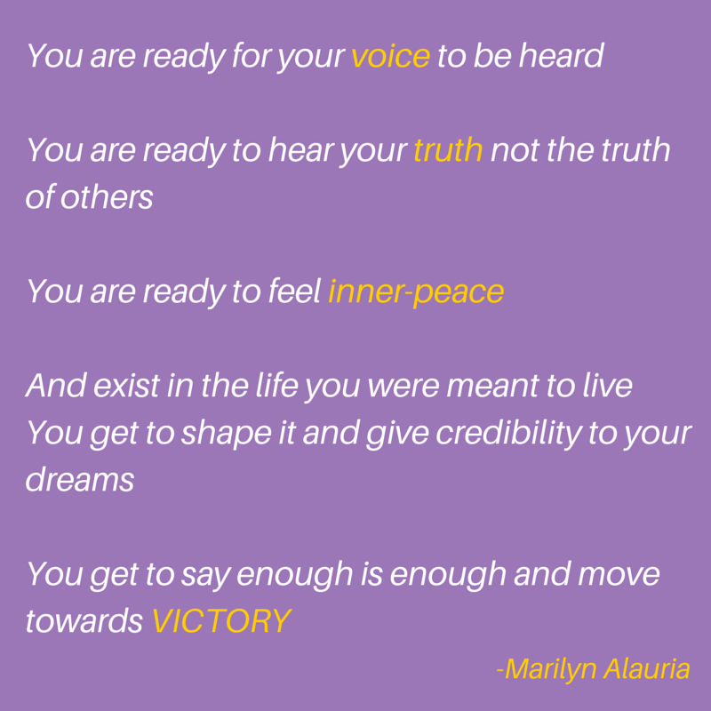

|  |
| --- |
| *myhealing house logo hq.png* |

*Like on* [*Facebook*](https://www.facebook.com/vera.novak.1)

*Connect* [*Twitter*](https://twitter.com/MyHealingHouse1)

*Connect with me on* [*LinkedIn*](http://ca.linkedin.com/in/veranovak)

